**Format to report your ADVANCED JAVA PROGRAMMING PROJECTS**

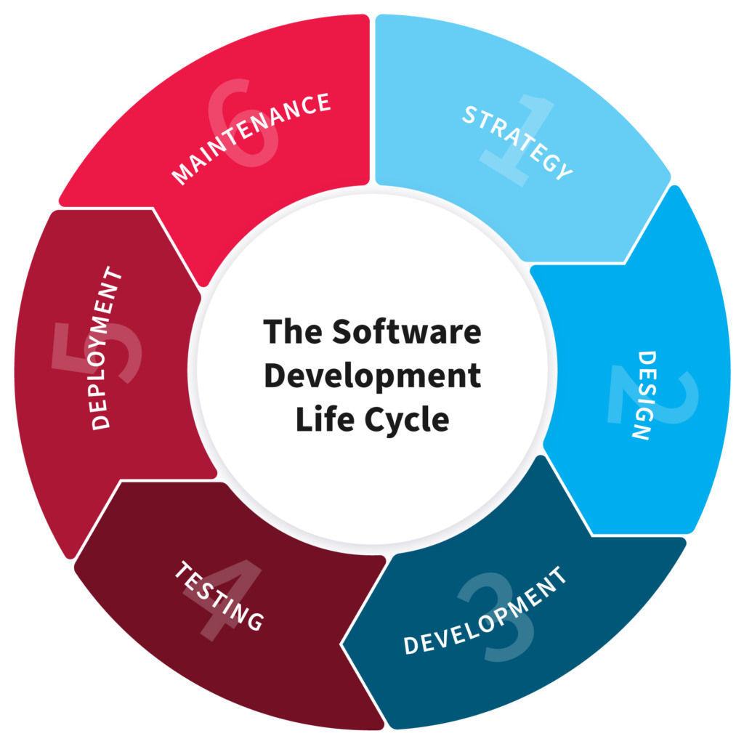

**NAME: Clebert NKURANGA**

**REG NO: 221023406**

**CLASS NO: 5**

**PROJECT NAME: Book-Store MIS**

1. **PLANNING**

Our java project is a management information system that is created for helping a bookstore to manage their sales, keep truck on the inventory, recording transactions, recording bookstore employees as users of the system.

**2. DESIGN**

* Technical requirements:
* Accessibility : Our system available and accessible to our employees in different regions where our bookstores are located in the country
* Authentication and authorization: Every user of the system will have to get an authentication bypass to access data and other functions.
* Maintainability: System needs to identify and resolve technical problems in an hour time period.
* Reliability: System must be able to operate 24/7 with minimum downtime as possible
* Easy friendly user interface: The project’s GUI must be simple to use for the users and also understable
* Functional requirements:
* Authentication: Every user of the system must provide a username and password given by the admin in order to access the system functionalities
* Product availability: Every book in the store must be available in the database of the system, and also the ability to add, edit and delete books in the database using the system
* Transaction record: Every transaction done by the employee over the system must be recorded in the database
* Employee record: Every employee must be recorded in database ,and the ability to delete and edit the users
* Receipts: Every transaction done for a customer must be printed and provided to them as a proof of book purchase

**3. DEVELOPMENT**

* Front-end: Designing the front-end of the system we used Netbeans for page designs and forms. Our forms included

Billing form, books form, login form, user form, and a loading splash

* Back-end:

JAVA: As our project was based on the java programing language, we used java as the back-end language and to make the system interactive.

Database: we used XAMPP to create, edit, modify database tables needed for our projects. Database tables (bill table, book table, user table).

**4. TESTING**

After the back-end and Front-end development the next step was to text if our system was interacting with the database created to see if every book add in the database was available to be displayed and if we can add, edit, delete, books in the database and we found a minor error in the edit button codes but we fixed that.

We also check if we can interact with the user table to see if they can bypass the authentication (login) and it work successfully.

We also checked if the transactions done by the users was recorded in the bill table in our database and if it is able to print receipts after every transaction and it also successfully.

And the last test we did was to restart the whole system was working form the splash loading page to the end of the transaction and our system was fully functioning with no bugs.

**5. DEPLOYMENT**

After conducting multiple test for our project the next and last process was to add it (the whole project and databases) in other laptops and see if it was actually working on the local network we create to simulate the workspace system interaction and it worked perfectly.